**PRACTICAL: 2**

**AIM:**

The transmission of information need to be secure over the communication channel and the data has to be confidential. To do so, steganography is the technique to concealing/hiding the secrete file, message, audio or video in some another format of file. OpenPuff is one of the free steganography tool for windows environment. Study and implement the practical approach for Steganography.

* Using DOS commands
* Using OpenPuff Tool

**THEORY: // (RELATED TO PRACTICAL)**

* Steganography is the technique of hiding secret data within an ordinary, non-secret, file or message in order to avoid detection; the secret data is then extracted at its destination.
* The purpose of steganography is to conceal and deceive. It is a form of covert communication and can involve the use of any medium to hide messages.

**CODE:**

|  |
| --- |
|  |

**OUTPUT: // (SCREENSHOT/S WITH EXPLANATION)**

* **Using DOS commands**

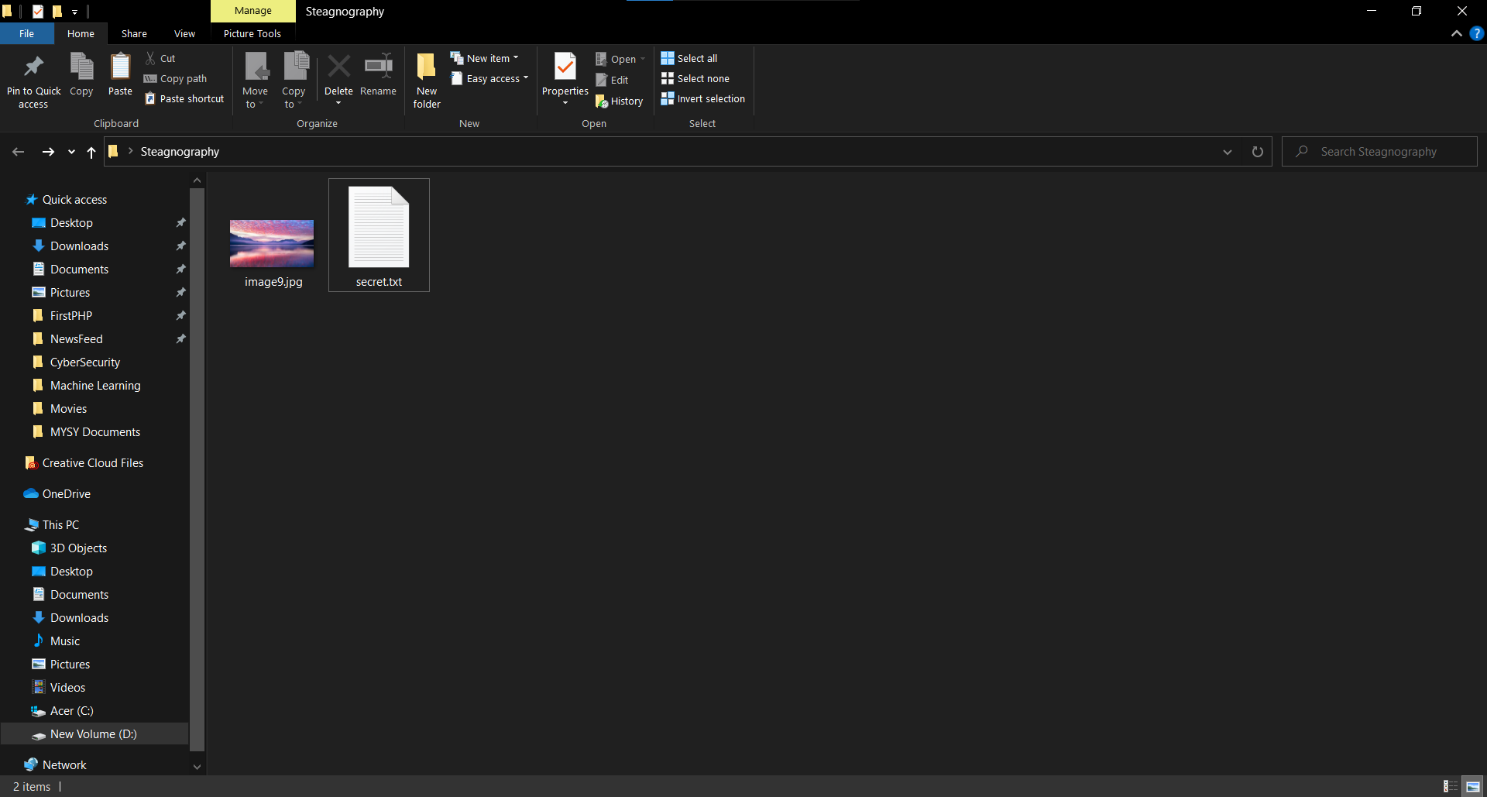

* Here we have two files one image file and other text file which we want to hide into image file.
* So open cmd and navigate to location in which your files are present.

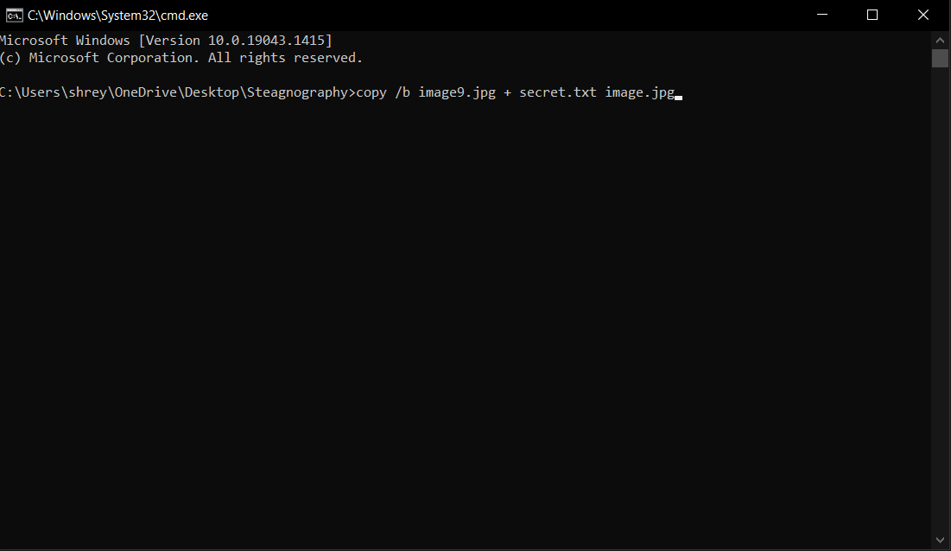

* Write this command “copy /b <your image file with extension> + <your secret file with extension> and <any image name file with same extension as you use for hiding extension>”
* So in our case image9.jpg and secret.txt will be copy into 3 file which is image.jpg

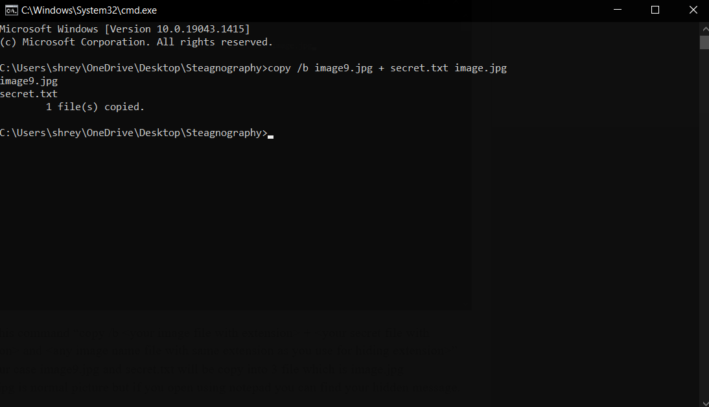

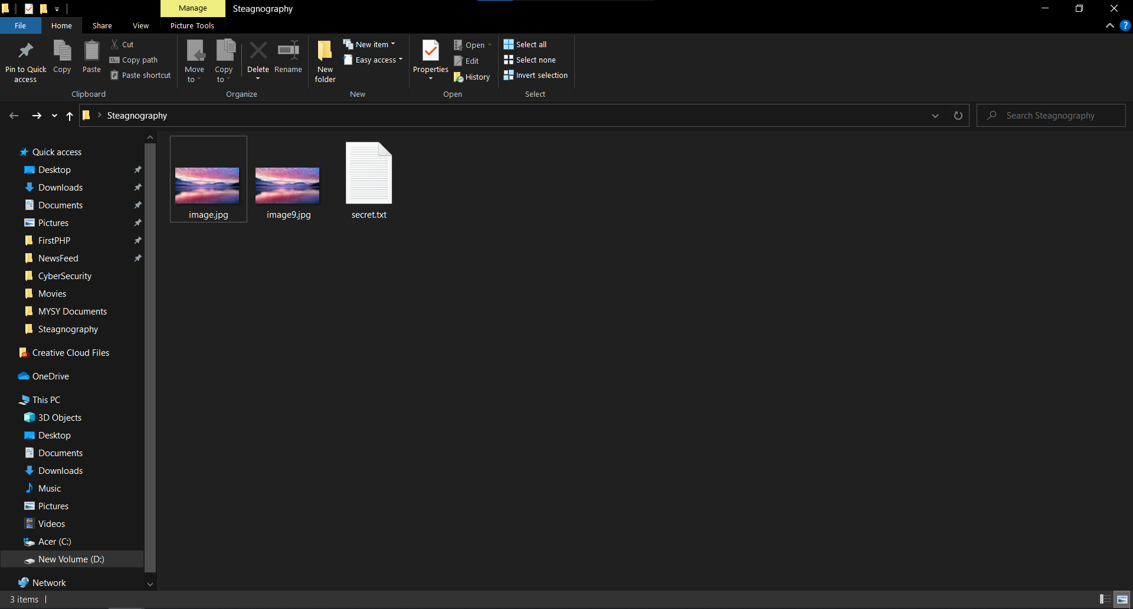

* Image.jpg is normal picture but if you open using notepad you can find your hidden message.

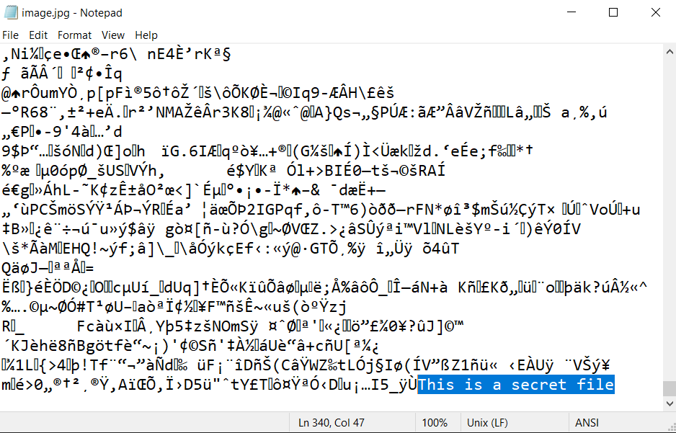

* Here we open our image.jpg (combine file of image9.jpg and secret.txt) in notepad and found our message at last.
* So we successfully hide our message and retrieve back from image file.
* **Using OpenPuff Tool**

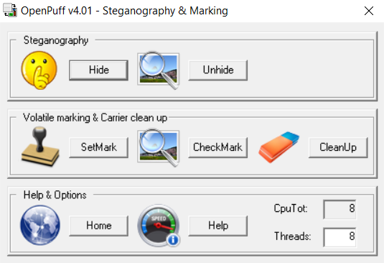

* Open OpenPuff tool and click on hide.

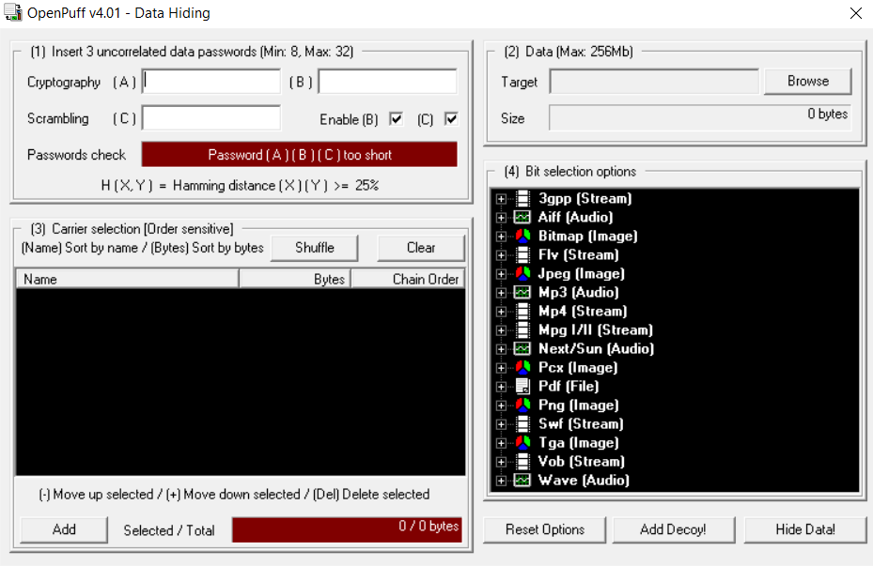

* Then enter different password into A, B and C field.

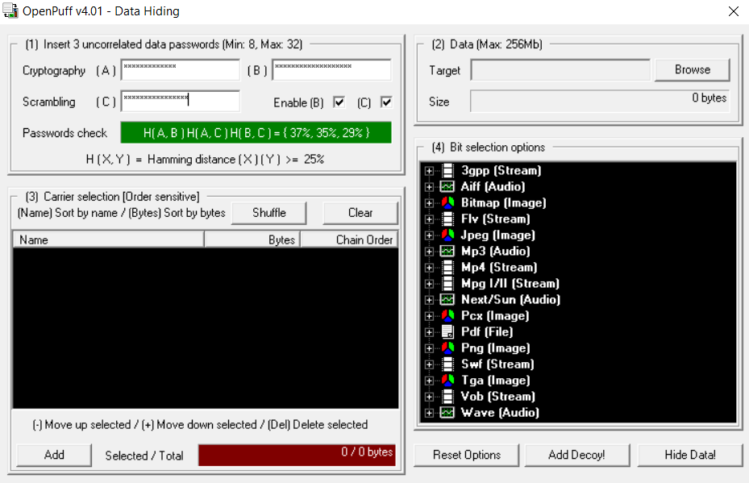

* Now select password in such a way that passwords check field become green in color.

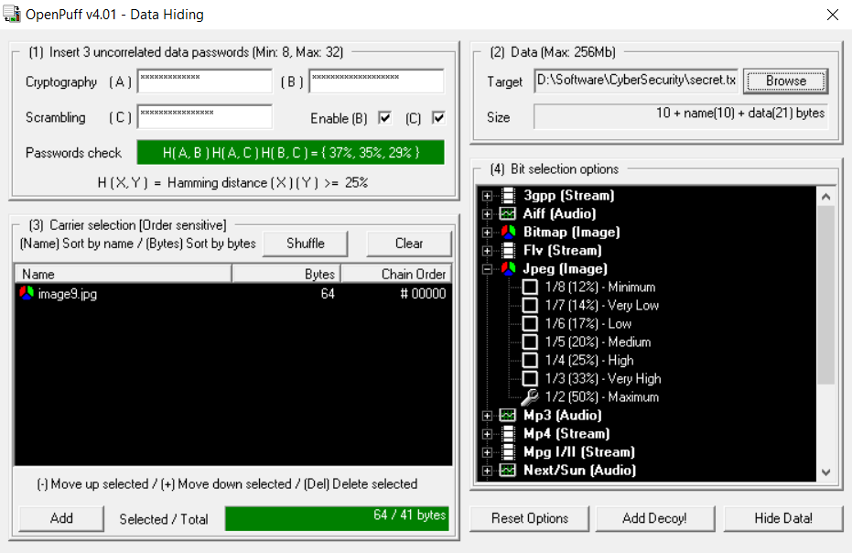

* Now select target file which you want to hide using browse button in data section.
* Now click on Add in Carrier selection field and select any image of your choice in which you want to hide (whatever file selected should have size greater than the target file).
* Now select what size you want of your image in bit selection field (Here we selected maximum).
* At last click on Hide Data and save your file on your location.
* Now navigate to file you just save , you will notice that it looks same as the image we selected for hiding but since we hide another file into it image file will be more than the original image file.



* Now click on unhide

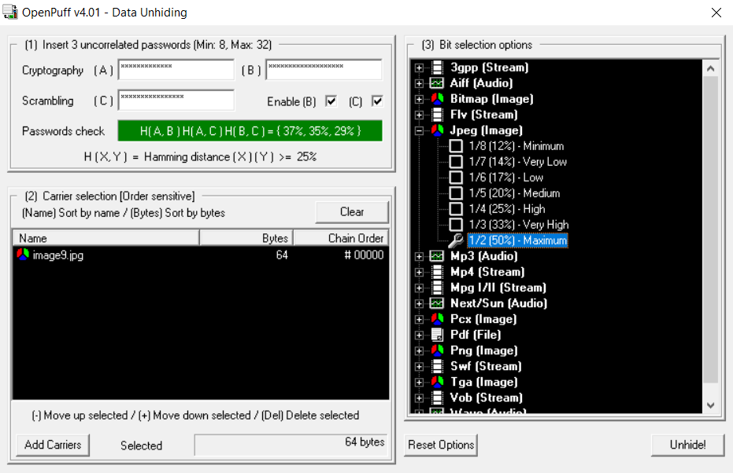

* Now Enter same password in A, B and C which we used for hiding.
* Select the Image file in which we hide other file.
* Select the same bit which we used for hiding the file.
* At last click on unhide and save file on your location and you will successfully unhide the file.

**LATEST APPLICATIONS: // (OF THIS PRACTICAL/TOOL IN REAL LIFE)**

* Confidential communication and secret data storing.
* Access control system for digital content distribution.
* Protection of data alteration.

**LEARNING OUTCOME:**

* Here we learn how we can hide one file into another file.

**REFERENCES:**

1. Reference: <https://embeddedsw.net/OpenPuff_Steganography_Home.html>